Movie Streaming Platform — DBMS Project

Submitted by: Yashita Bahrani (BT23CSE218)
Submitted to: Mr. Karan Potdukhe Sir

1. ER Diagram
Entities (Tables):
- users: Stores core account credentials and status.
- profiles: Manages individual user profiles under a single account (e.g., "Kids," "John's Profile").
- plans: Defines the available subscription plans (e.g., Basic, Premium 4K).
- subscriptions: Tracks the relationship between a user and their chosen plan over time.
- movies: Contains all metadata for movies, such as title, duration, and release date.
- genres: A lookup table for movie genres (e.g., Action, Romance).
- movie_genres: A junction table creating a many-to-many relationship between movies and genres.
- watch_history: Logs the viewing activity for each profile.
- ratings: Stores the 1-5 star ratings given by a profile to a movie.
- reviews: Stores detailed text reviews written by profiles for movies.
- playlists: Allows profiles to create named collections of movies.
- playlist_movies: A junction table linking playlists to the movies they contain.

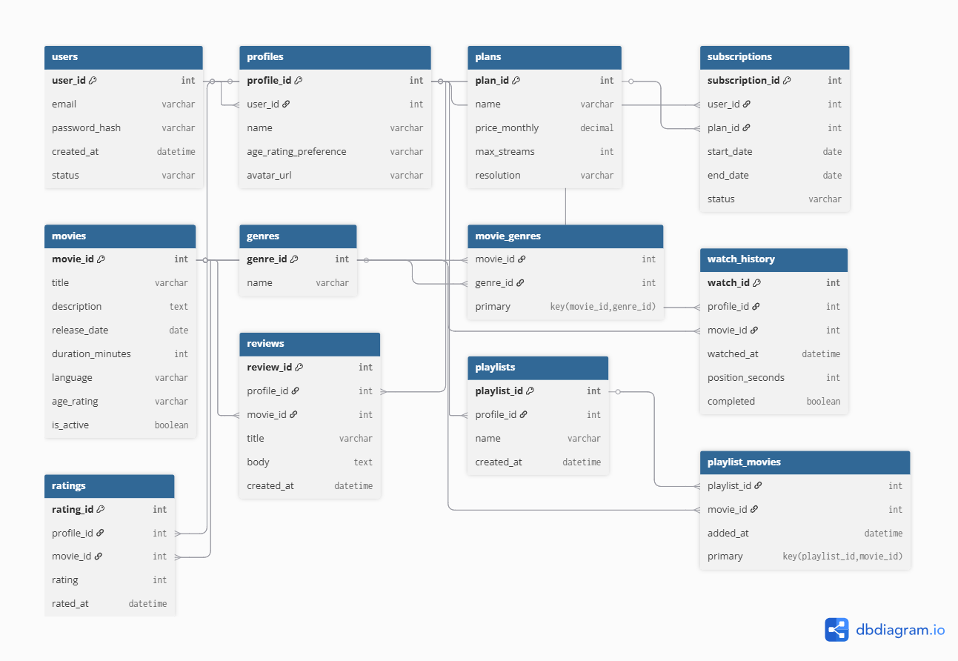

Cardinalities:
Relationship | Cardinality | Meaning
users → profiles | 1 → N | One user can create multiple profiles (like Netflix).
users → subscriptions | 1 → N | One user may have multiple historical subscriptions.
plans → subscriptions | 1 → N | One plan can be chosen by many users.
movies ↔ genres | M ↔ M | Many movies can belong to many genres — via movie_genres.
profiles → watch_history | 1 → N | Each profile has multiple watch history entries.
profiles → ratings | 1 → N | Each profile can rate many movies.
profiles → reviews | 1 → N | Each profile can review many movies.
profiles → playlists | 1 → N | Each profile can create multiple playlists.
playlists ↔ movies | M ↔ M | Many movies can appear in many playlists — via playlist_movies.

2. SQL Implementation

CREATE database movie_streaming_db;
USE movie_streaming_db;

CREATE TABLE users (
user_id INT AUTO_INCREMENT PRIMARY KEY,
email VARCHAR(255) UNIQUE NOT NULL,
password_hash VARCHAR(255) NOT NULL,
created_at TIMESTAMP DEFAULT CURRENT_TIMESTAMP,
status ENUM('active','suspended') DEFAULT 'active'
);

CREATE TABLE profiles (
profile_id INT AUTO_INCREMENT PRIMARY KEY,
user_id INT,
name VARCHAR(100) NOT NULL,
age_rating_preference VARCHAR(10) DEFAULT 'PG-13',
avatar_url TEXT,
FOREIGN KEY (user_id) REFERENCES users(user_id) ON DELETE CASCADE
);

CREATE TABLE plans (
plan_id INT AUTO_INCREMENT PRIMARY KEY,
name VARCHAR(50) UNIQUE NOT NULL,
price_monthly DECIMAL(6,2) NOT NULL,
max_streams INT NOT NULL,
resolution VARCHAR(20)
);

CREATE TABLE subscriptions (
subscription_id INT AUTO_INCREMENT PRIMARY KEY,
user_id INT,
plan_id INT,
start_date DATE NOT NULL,
end_date DATE,
status ENUM('active','expired','cancelled') DEFAULT 'active',
FOREIGN KEY (user_id) REFERENCES users(user_id) ON DELETE CASCADE,
FOREIGN KEY (plan_id) REFERENCES plans(plan_id) ON DELETE RESTRICT
);

CREATE TABLE movies (
movie_id INT AUTO_INCREMENT PRIMARY KEY,
title VARCHAR(255) NOT NULL,
description TEXT,
release_date DATE,
duration_minutes INT CHECK (duration_minutes > 0),
language VARCHAR(50),
age_rating VARCHAR(10),
is_active BOOLEAN DEFAULT TRUE
);

CREATE TABLE genres (
genre_id INT AUTO_INCREMENT PRIMARY KEY,
name VARCHAR(50) UNIQUE NOT NULL
);

CREATE TABLE movie_genres (
movie_id INT,
genre_id INT,
PRIMARY KEY (movie_id, genre_id),
FOREIGN KEY (movie_id) REFERENCES movies(movie_id) ON DELETE CASCADE,
FOREIGN KEY (genre_id) REFERENCES genres(genre_id) ON DELETE CASCADE
);

CREATE TABLE watch_history (
watch_id INT AUTO_INCREMENT PRIMARY KEY,
profile_id INT,
movie_id INT,
watched_at TIMESTAMP DEFAULT CURRENT_TIMESTAMP,
position_seconds INT,
completed BOOLEAN DEFAULT FALSE,
FOREIGN KEY (profile_id) REFERENCES profiles(profile_id) ON DELETE CASCADE,
FOREIGN KEY (movie_id) REFERENCES movies(movie_id) ON DELETE CASCADE
);

CREATE TABLE ratings (
rating_id INT AUTO_INCREMENT PRIMARY KEY,
profile_id INT,
movie_id INT,
rating INT CHECK (rating BETWEEN 1 AND 5),
rated_at TIMESTAMP DEFAULT CURRENT_TIMESTAMP,
UNIQUE (profile_id, movie_id),
FOREIGN KEY (profile_id) REFERENCES profiles(profile_id) ON DELETE CASCADE,
FOREIGN KEY (movie_id) REFERENCES movies(movie_id) ON DELETE CASCADE
);

CREATE TABLE reviews (
review_id INT AUTO_INCREMENT PRIMARY KEY,
profile_id INT,
movie_id INT,
title VARCHAR(100),
body TEXT,
created_at TIMESTAMP DEFAULT CURRENT_TIMESTAMP,
FOREIGN KEY (profile_id) REFERENCES profiles(profile_id) ON DELETE CASCADE,
FOREIGN KEY (movie_id) REFERENCES movies(movie_id) ON DELETE CASCADE
);

CREATE TABLE playlists (
playlist_id INT AUTO_INCREMENT PRIMARY KEY,
profile_id INT,
name VARCHAR(100) NOT NULL,
created_at TIMESTAMP DEFAULT CURRENT_TIMESTAMP,
FOREIGN KEY (profile_id) REFERENCES profiles(profile_id) ON DELETE CASCADE
);

CREATE TABLE playlist_movies (
playlist_id INT,
movie_id INT,
added_at TIMESTAMP DEFAULT CURRENT_TIMESTAMP,
PRIMARY KEY (playlist_id, movie_id),
FOREIGN KEY (playlist_id) REFERENCES playlists(playlist_id) ON DELETE CASCADE,
FOREIGN KEY (movie_id) REFERENCES movies(movie_id) ON DELETE CASCADE
);

SHOW TABLES;
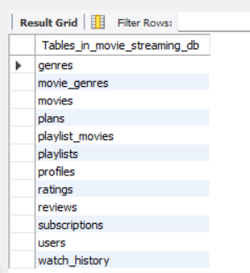

4. Sample Data: INSERT statements

INSERT INTO users (email, password_hash, status) VALUES
('rohan.sharma@example.com', 'hash123_rohan', 'active'),
('priya.patel@example.com', 'hash456_priya', 'active'),
('vikram.singh@example.com', 'hash789_vikram', 'suspended'),
('aisha.khan@example.com', 'hash101_aisha', 'active'),
('arjun.mehta@example.com', 'hash112_arjun', 'active');
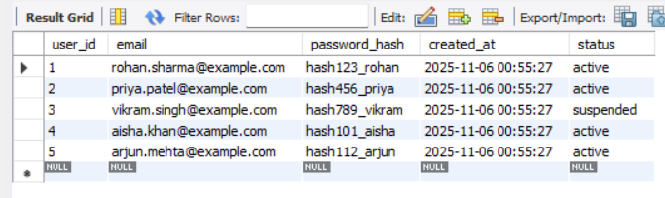

INSERT INTO plans (name, price_monthly, max_streams, resolution) VALUES
('Basic Mobile', 199.00, 1, '480p'),
('Standard HD', 499.00, 2, '1080p'),
('Premium 4K', 799.00, 4, '4K+HDR'),
('Family Plan', 649.00, 4, '1080p'),
('Student Offer', 149.00, 1, '720p');
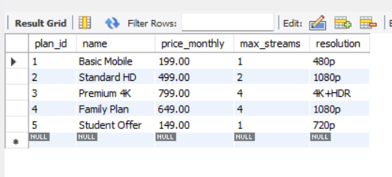

INSERT INTO subscriptions (user_id, plan_id, start_date, end_date, status) VALUES
(1, 2, '2025-01-15', NULL, 'active'),
(2, 3, '2025-02-20', NULL, 'active'),
(3, 1, '2024-11-10', '2025-05-10', 'cancelled'),
(4, 4, '2025-03-01', NULL, 'active'),
(5, 2, '2024-08-05', '2025-08-04', 'expired');
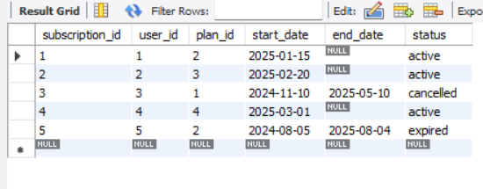

INSERT INTO profiles (user_id, name, age_rating_preference, avatar_url) VALUES
(1, 'Rohan Main', 'PG-13', 'http://example.com/avatars/rohan.jpg'),
(1, 'Rohan Kids', 'G', 'http://example.com/avatars/rohan_kids.jpg'),
(2, 'Priya', 'R', 'http://example.com/avatars/priya.jpg'),
(4, 'Aisha Movies', 'PG-13', 'http://example.com/avatars/aisha.jpg'),
(5, 'Arjun Watch', 'G', 'http://example.com/avatars/arjun.jpg');
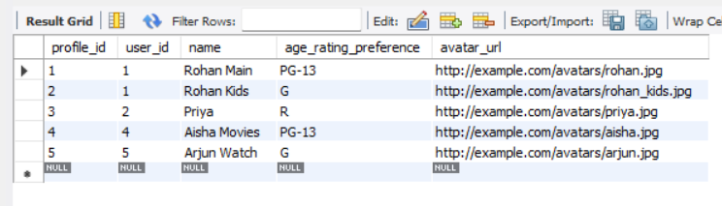

INSERT INTO genres (name) VALUES
('Action'),
('Romance'),
('Comedy'),
('Drama'),
('Thriller');
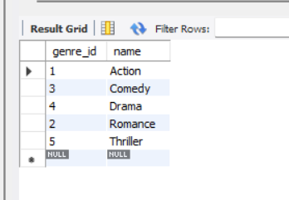

INSERT INTO movies (title, description, release_date, duration_minutes, language, age_rating, is_active) VALUES
('3 Idiots', 'Two friends are searching for their long lost companion. They revisit their college days and recall the memories of their friend who inspired them to think differently.', '2009-12-25', 170, 'Hindi', 'PG-13', TRUE),
('Lagaan', 'The people of a small village in Victorian India stake their future on a game of cricket against their ruthless British rulers.', '2001-06-15', 224, 'Hindi', 'PG', TRUE),
('Dilwale Dulhania Le Jayenge', 'When Raj meets Simran in Europe, it isn`t love at first sight but when Simran moves to India for an arranged marriage, love strikes.', '1995-10-20', 189, 'Hindi', 'G', TRUE),
('Andhadhun', 'A series of mysterious events change the life of a blind pianist, who must now report a crime that he should technically know nothing of.', '2018-10-05', 139, 'Hindi', 'R', TRUE),
('Gangs of Wasseypur', 'A clash between Sultan and Shahid Khan leads to the expulsion of Khan from Wasseypur, and ignites a deadly blood feud spanning three generations.', '2012-06-22', 321, 'Hindi', 'R', TRUE);
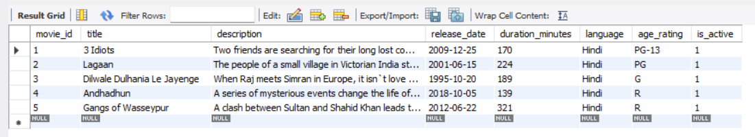

INSERT INTO movie_genres (movie_id, genre_id) VALUES
(1, 3), -- 3 Idiots -> Comedy
(1, 4), -- 3 Idiots -> Drama
(2, 4), -- Lagaan -> Drama
(3, 2), -- DDLJ -> Romance
(5, 1), -- Gangs of Wasseypur -> Action
(5, 5); -- Gangs of Wasseypur -> Thriller
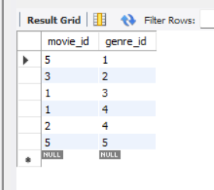

INSERT INTO watch_history (profile_id, movie_id, position_seconds, completed) VALUES
(1, 1, 7200, TRUE), -- Rohan Main watched 3 Idiots
(2, 3, 3600, FALSE), -- Priya watched DDLJ
(3, 2, 8400, TRUE), -- Priya watched Lagaan
(4, 4, 1200, FALSE), -- Aisha watched Andhadhun
(1, 5, 9000, FALSE); -- Rohan Main watched Gangs of Wasseypur
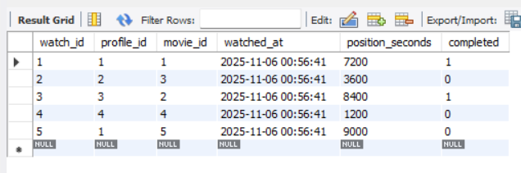

INSERT INTO ratings (profile_id, movie_id, rating) VALUES
(1, 1, 5), -- Rohan Main rated 3 Idiots
(2, 3, 5), -- Priya rated DDLJ
(3, 2, 4), -- Priya rated Lagaan
(4, 4, 5), -- Aisha rated Andhadhun
(1, 2, 4); -- Rohan Main rated Lagaan
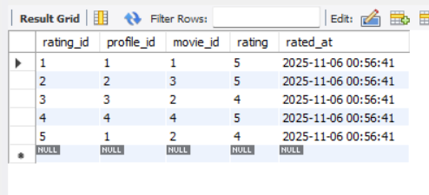

INSERT INTO reviews (profile_id, movie_id, title, body) VALUES
(1, 1, 'An absolute masterpiece!', 'One of the best movies ever made about the education system. A must watch!'),
(2, 3, 'Classic Bollywood Romance', 'Shah Rukh Khan and Kajol are iconic. The story is timeless.'),
(3, 2, 'Inspirational and Epic', 'A gripping story of courage and determination. The cricket match was legendary.'),
(4, 4, 'Mind-bending thriller', 'Kept me on the edge of my seat until the very end. The plot twists are incredible.'),
(1, 5, 'A Gritty Saga', 'Raw, powerful, and unforgettable. A very realistic portrayal of crime and power struggles.');
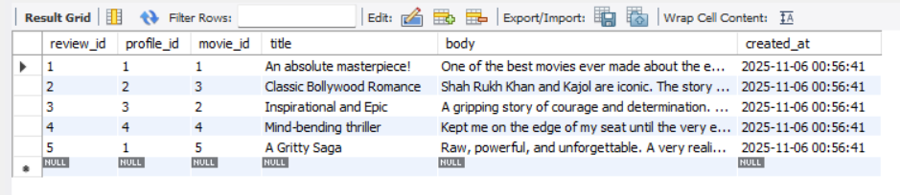

INSERT INTO playlists (profile_id, name) VALUES
(1, 'Weekend Binge'),
(2, '90s Classics'),
(4, 'My Top Thrillers'),
(1, 'Feel Good Movies'),
(5, 'Family Movie Night');
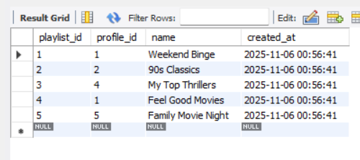

INSERT INTO playlist_movies (playlist_id, movie_id) VALUES
(1, 1), -- Add '3 Idiots' to 'Weekend Binge'
(1, 5), -- Add 'Gangs of Wasseypur' to 'Weekend Binge'
(2, 3), -- Add 'DDLJ' to '90s Classics'
(3, 4), -- Add 'Andhadhun' to 'My Top Thrillers'
(4, 1); -- Add '3 Idiots' to 'Feel Good Movies'
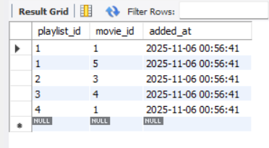

5. Advanced SQL Queries (30)

a. Joins (INNER, LEFT, RIGHT, SELF, CROSS)

- Get a list of all users who have an active subscription and show their email and the name of their subscription plan.
SELECT
u.email,
p.name AS plan_name,
s.start_date
FROM users u
INNER JOIN subscriptions s ON u.user_id = s.user_id
INNER JOIN plans p ON s.plan_id = p.plan_id
WHERE s.status = 'active';
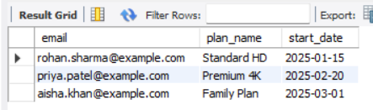

- List all movies and the number of times each has been watched to completion. Include movies that have never been watched.
SELECT
m.title,
COUNT(w.watch_id) AS times_completed
FROM movies m
LEFT JOIN watch_history w ON m.movie_id = w.movie_id AND w.completed = TRUE
GROUP BY m.title
ORDER BY times_completed DESC;
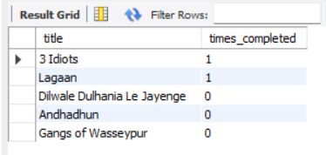

- Show all genres and the titles of movies associated with them. Ensure that genres with no movies are still listed.
SELECT
g.name AS genre,
m.title
FROM movie_genres mg
RIGHT JOIN genres g ON mg.genre_id = g.genre_id
LEFT JOIN movies m ON mg.movie_id = m.movie_id
ORDER BY g.name;
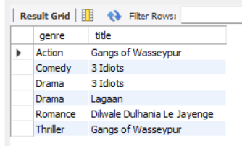

- Find pairs of profiles that belong to the same user account.
SELECT
u.email,
p1.name AS profile1_name,
p2.name AS profile2_name
FROM profiles p1
INNER JOIN profiles p2 ON p1.user_id = p2.user_id AND p1.profile_id < p2.profile_id
INNER JOIN users u ON p1.user_id = u.user_id;
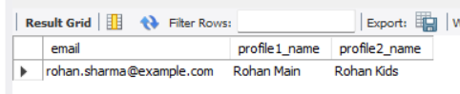
- Generate a report that shows every possible combination of a user profile and a genre, to help create a recommendation matrix.
SELECT
p.name AS profile_name,
g.name AS genre_to_recommend
FROM profiles p
CROSS JOIN genres g
ORDER BY p.name, g.name;


b. Subqueries (IN, EXISTS, ANY, ALL)
- Find the email addresses of all users who have subscribed to a plan that costs more than 500 per month.
SELECT email
FROM users
WHERE user_id IN (
SELECT user_id
FROM subscriptions
WHERE plan_id IN (
SELECT plan_id
FROM plans
WHERE price_monthly > 500.00
)
);
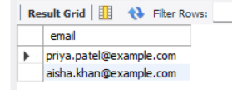

- List all movies that have not received any ratings.
SELECT title, release_date
FROM movies
WHERE movie_id NOT IN (
SELECT DISTINCT movie_id
FROM ratings
);
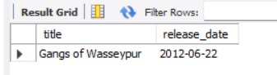

- Find all users who have at least one profile that has written a review.
SELECT email
FROM users u
WHERE EXISTS (
SELECT 1
FROM profiles p
JOIN reviews r ON p.profile_id = r.profile_id
WHERE p.user_id = u.user_id
);
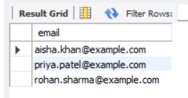

- Find a movie that is rated higher than ANY movie in the 'Comedy' genre.
SELECT DISTINCT m.title
FROM movies m
JOIN ratings r ON m.movie_id = r.movie_id
WHERE r.rating > ANY (
SELECT r_inner.rating
FROM ratings r_inner
JOIN movie_genres mg ON r_inner.movie_id = mg.movie_id
JOIN genres g ON mg.genre_id = g.genre_id
WHERE g.name = 'Drama'
);
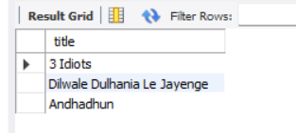

- Find the movie(s) with the highest rating, better than or equal to ALL other ratings.
SELECT m.title, r.rating
FROM movies m
JOIN ratings r ON m.movie_id = r.movie_id
WHERE r.rating >= ALL (
SELECT rating FROM ratings
);
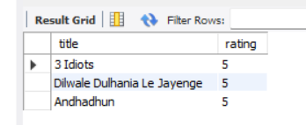

c. Aggregate Functions, GROUP BY + HAVING
- Calculate the average rating for each movie and only show movies with an average rating of 4.5 or higher.
SELECT
m.title,
AVG(r.rating) AS average_rating
FROM movies m
JOIN ratings r ON m.movie_id = r.movie_id
GROUP BY m.title
HAVING AVG(r.rating) >= 4.5
ORDER BY average_rating DESC;
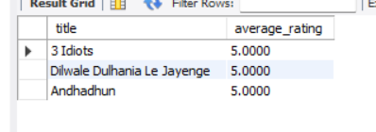

- Find the total number of profiles associated with each user subscription status ('active', 'expired', 'cancelled').
SELECT
s.status,
COUNT(p.profile_id) AS number_of_profiles
FROM subscriptions s
JOIN users u ON s.user_id = u.user_id
JOIN profiles p ON u.user_id = p.user_id
GROUP BY s.status;
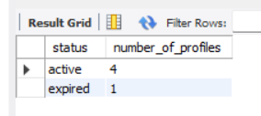

- Identify users who have more than one active profile and are on a 'Premium 4K' plan.
SELECT
u.email
FROM users u
JOIN profiles p ON u.user_id = p.user_id
JOIN subscriptions s ON u.user_id = s.user_id
JOIN plans pl ON s.plan_id = pl.plan_id
WHERE s.status = 'active' AND pl.name = 'Standard HD'
GROUP BY u.email
HAVING COUNT(p.profile_id) > 1;
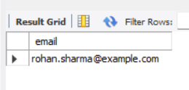

- Find the total watch time (in minutes) for each genre.
SELECT
g.name AS genre,
SUM(m.duration_minutes) AS total_minutes_watched
FROM genres g
JOIN movie_genres mg ON g.genre_id = mg.genre_id
JOIN movies m ON mg.movie_id = m.movie_id
JOIN watch_history wh ON m.movie_id = wh.movie_id
WHERE wh.completed = TRUE
GROUP BY g.name
ORDER BY total_minutes_watched DESC;
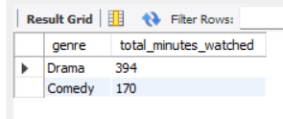

- Find the genre with the highest average movie duration.
SELECT
g.name AS genre,
AVG(m.duration_minutes) as avg_duration
FROM genres g
JOIN movie_genres mg ON g.genre_id = mg.genre_id
JOIN movies m ON mg.movie_id = m.movie_id
GROUP BY g.name
ORDER BY avg_duration DESC
LIMIT 1;
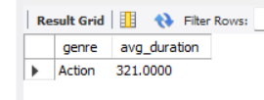

d. Nested queries and correlated subqueries
- List all movies watched by profiles belonging to the user 'priya.patel@example.com'.
SELECT DISTINCT m.title
FROM movies m
WHERE m.movie_id IN (
SELECT wh.movie_id
FROM watch_history wh
WHERE wh.profile_id IN (
SELECT p.profile_id
FROM profiles p
WHERE p.user_id = (
SELECT u.user_id
FROM users u
WHERE u.email = 'priya.patel@example.com'
)
)
);
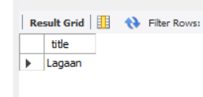

- For each user, find the date of their most recent subscription.
SELECT u.email, s1.start_date, s1.status
FROM users u
JOIN subscriptions s1 ON u.user_id = s1.user_id
WHERE s1.start_date = (
SELECT MAX(s2.start_date)
FROM subscriptions s2
WHERE s2.user_id = s1.user_id
);
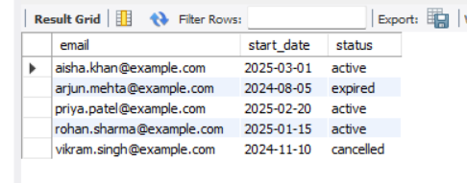

- Find movies that have a rating higher than the average rating of all movies released in the same year.
SELECT m1.title, m1.release_date, r.rating
FROM movies m1
JOIN ratings r ON m1.movie_id = r.movie_id
WHERE r.rating > (
SELECT AVG(r2.rating)
FROM ratings r2
JOIN movies m2 ON r2.movie_id = m2.movie_id
WHERE YEAR(m2.release_date) != YEAR(m1.release_date)
);
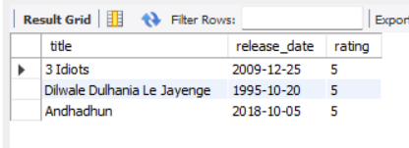

- List all playlists that contain at least one movie from the 'Action' genre.
SELECT p.name
FROM playlists p
WHERE EXISTS (
SELECT 1
FROM playlist_movies pm
JOIN movie_genres mg ON pm.movie_id = mg.movie_id
JOIN genres g ON mg.genre_id = g.genre_id
WHERE pm.playlist_id = p.playlist_id AND g.name = 'Action'
);
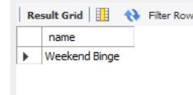

- For each genre, find the title of its longest movie.
SELECT g.name AS genre, m.title, m.duration_minutes
FROM genres g
JOIN movie_genres mg ON g.genre_id = mg.genre_id
JOIN movies m ON mg.movie_id = m.movie_id
WHERE m.duration_minutes = (
SELECT MAX(m2.duration_minutes)
FROM movies m2
JOIN movie_genres mg2 ON m2.movie_id = mg2.movie_id
WHERE mg2.genre_id = g.genre_id
);
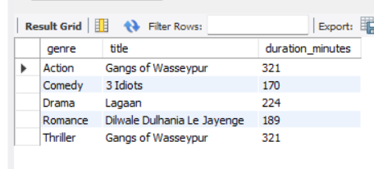

e. Set operations (UNION, INTERSECT, EXCEPT)
- Create a consolidated list of a specific user's favorite content, showing both their highly-rated movies (4 stars or more) and the playlists they created.
SELECT
m.title AS user_favorites
FROM movies m
WHERE m.movie_id IN (
SELECT r.movie_id
FROM ratings r
WHERE r.rating >= 4 AND r.profile_id IN (
SELECT p.profile_id
FROM profiles p
WHERE p.user_id = 1
)
)
UNION
SELECT
pl.name AS user_favorites
FROM playlists pl
WHERE pl.profile_id IN (
SELECT p.profile_id
FROM profiles p
WHERE p.user_id = 1
);


- Find movies that are classified as both 'Drama' and 'Comedy'.
SELECT m.title
FROM movies m
WHERE m.movie_id IN (
SELECT mg.movie_id
FROM movie_genres mg
JOIN genres g ON mg.genre_id = g.genre_id
WHERE g.name = 'Drama'
) AND m.movie_id IN (
SELECT mg.movie_id
FROM movie_genres mg
JOIN genres g ON mg.genre_id = g.genre_id
WHERE g.name = 'Comedy'
);
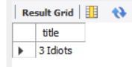

- List all 'Action' movies that have NOT been added to the 'Weekend Binge' playlist.
SELECT m.title
FROM movies m
JOIN movie_genres mg ON m.movie_id = mg.movie_id
JOIN genres g ON mg.genre_id = g.genre_id
WHERE g.name = 'Action'
AND m.movie_id NOT IN (
SELECT pm.movie_id
FROM playlist_movies pm
JOIN playlists p ON pm.playlist_id = p.playlist_id
WHERE p.name = '90s Classics'
);
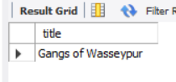

- Generate a "Churn Risk Report" that identifies two types of at-risk users: 1) Users on expensive plans who haven't watched anything in the last 90 days, and 2) Users whose accounts are suspended but still have an active, paying subscription.
SELECT
u.email,
'Status: Engaged High-Value Customer' AS report_reason,
p.name AS plan_name,
p.price_monthly
FROM users u
JOIN subscriptions s ON u.user_id = s.user_id
JOIN plans p ON s.plan_id = p.plan_id
WHERE
p.price_monthly > 400.00
AND s.status = 'active'
AND u.user_id IN (
SELECT DISTINCT p.user_id
FROM profiles p
JOIN watch_history wh ON p.profile_id = wh.profile_id
WHERE wh.watched_at >= CURDATE() - INTERVAL 90 DAY
)
UNION ALL
SELECT
u.email,
'Risk: Suspended Account with Non-Renewing Plan' AS report_reason,
p.name AS plan_name,
p.price_monthly
FROM users u
JOIN subscriptions s ON u.user_id = s.user_id
JOIN plans p ON s.plan_id = p.plan_id
WHERE
u.status = 'suspended'
AND s.status = 'cancelled';
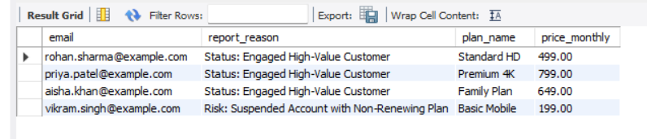

f. Advanced SQL
- Using a CTE, first find all movies with an average rating above 4.0, and then display their titles and genres.
WITH HighlyRatedMovies AS (
SELECT movie_id, AVG(rating) AS avg_rating
FROM ratings
GROUP BY movie_id
HAVING AVG(rating) > 4.0
)
SELECT
m.title,
g.name AS genre
FROM movies m
JOIN HighlyRatedMovies hrm ON m.movie_id = hrm.movie_id
JOIN movie_genres mg ON m.movie_id = mg.movie_id
JOIN genres g ON mg.genre_id = g.genre_id
ORDER BY m.title;
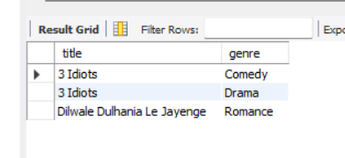

- For each genre, rank movies by their release date (newest first).
SELECT
m.title,
g.name AS genre,
m.release_date,
RANK() OVER (PARTITION BY g.name ORDER BY m.release_date DESC) as date_rank
FROM movies m
JOIN movie_genres mg ON m.movie_id = mg.movie_id
JOIN genres g ON mg.genre_id = g.genre_id;
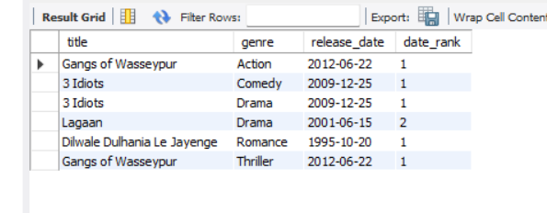

- For each movie rating, show the rating itself and the average rating for that specific movie.
SELECT
m.title,
r.rating,
AVG(r.rating) OVER (PARTITION BY m.title) AS movie_average_rating
FROM ratings r
JOIN movies m ON r.movie_id = m.movie_id
ORDER BY m.title;
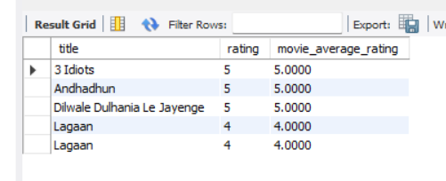

- Find the top 3 longest movies in each genre.
WITH RankedMovies AS (
SELECT
m.title,
g.name AS genre,
m.duration_minutes,
ROW_NUMBER() OVER(PARTITION BY g.name ORDER BY m.duration_minutes DESC) as rn
FROM movies m
JOIN movie_genres mg ON m.movie_id = mg.movie_id
JOIN genres g ON mg.genre_id = g.genre_id
)
SELECT title, genre, duration_minutes
FROM RankedMovies
WHERE rn <= 3;
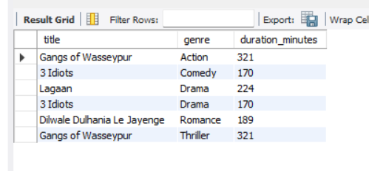

- For a specific profile's watch history, show what movie was watched immediately before and after each movie.
SELECT
m.title,
wh.watched_at,
LAG(m.title, 1, 'N/A') OVER (ORDER BY wh.watched_at) AS previous_movie,
LEAD(m.title, 1, 'N/A') OVER (ORDER BY wh.watched_at) AS next_movie
FROM watch_history wh
JOIN movies m ON wh.movie_id = m.movie_id
WHERE wh.profile_id = 1 -- Assuming we are checking for the profile with ID 1
ORDER BY wh.watched_at;


- Calculate the running total of monthly revenue from all 'Standard HD' subscriptions.
WITH MonthlyRevenue AS (
SELECT
DATE_FORMAT(start_date, '%Y-%m-01') AS month,
SUM(p.price_monthly) as monthly_total
FROM subscriptions s
JOIN plans p ON s.plan_id = p.plan_id
WHERE p.name = 'Standard HD'
GROUP BY month
)
SELECT
month,
monthly_total,
SUM(monthly_total) OVER (ORDER BY month) AS running_total_revenue
FROM MonthlyRevenue;
